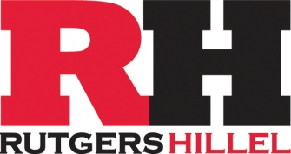

February 3, 2017

Dear President Barchi:

On behalf of Hillel at Rutgers University and Hillel International, the largest Jewish student organization in the world, we wish to express our support for the statements and actions you have outlined to protect students at Rutgers University from the consequences of the Executive Order issued on Friday, January 27, 2017 regarding refugees and visa- and green card holders from certain countries in the Middle East.

Jewish history and scripture teach us unequivocally to care for the “strangers” in our midst. Upon leaving Egypt, the ancient Israelites are told, “you shall not oppress a stranger, for you know the feelings of the stranger, since you were strangers in the land of Egypt.” (Exodus 23:9) On 36 different occasions, our Torah commands us to remember the experience of being foreigners, strangers, and victims of oppression, and our people has been imbued with that spirit ever since.

Throughout our history, until the establishment of the modern State of Israel, Jews have been minorities within the many cultures we have lived, and have often been the subject of restrictions on where we could live and study. We know if this order were aimed at Jewish students we would ask you and all our fellow students to stand with us. As such, we unequivocally stand with all students who find that this order will affect themselves or their families. And we stand in solidarity with the university community in upholding the values of freedoms of speech, press, and assembly that are core both to American life and the life of the academy.

We are ready to do whatever we can as a campus organization, especially one affiliated with a global movement, to assist you in your efforts to make our university a place of learning, growth, and opportunity for all.

Sincerely,
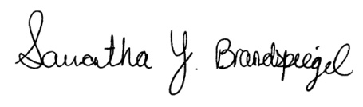
Samantha Brandspiegel, President, Student Board, Rutgers Hillel _________________________

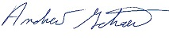
Andrew Getraer, Executive Director, Rutgers Hillel

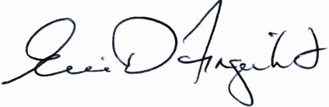
Eric Fingerhut, President and CEO, Hillel International

